We want to make it easier for disabled people to travel on trains. We are looking for people to help.
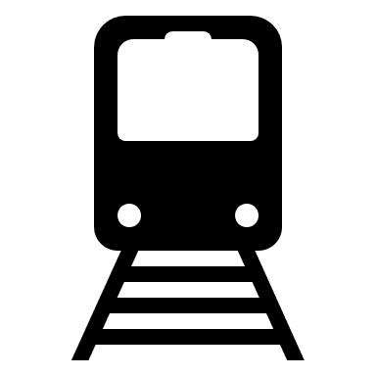
Do you use trains? Choose an item.
Can you tell us what would make using trains easier?
Click or tap here to enter text.
Can you tell us what makes using trains harder?
Click or tap here to enter text.
Do you have access to email and the internet?
Choose an item.

Can you join online meetings on Zoom?
Choose an item.

If you said yes, then you may be the person we need to help us.

Please answer these questions about yourself
Your name Click or tap here to enter text.
What is your email address? Click or tap here to enter text.
What is your address for post?
Click or tap here to enter text.
What is the easiest way for us to talk to each other
Choose an item.

Tell us about a train journey you took recently,
Where did you go? Click or tap here to enter text.
Did you enjoy it? Choose an item.

Can you explain why you did or didn’t enjoy it?
Click or tap here to enter text.

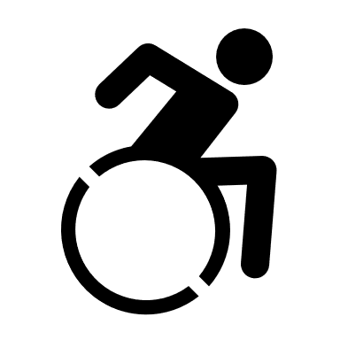
Do you go to any other groups which represent disabled people?
Choose an item.
Why do you want to help make train travel easier for disabled people? Click or tap here to enter text.

Email your completed application to Accessibility@chilternrailways.co.uk or post it to Accessibility Panel, FREEPOST Chiltern Railways

